**ST. THOMAS’ COLLEGE OF ENGINEERING AND TECHNOLOGY**

**REPORT ON GUESS APP**

**BY GROUP NO. –15**

**MEMBERS** –

• **SANGITA POREY (ROLL 57)**

• **RISHAB PRASAD (ROLL 58)**

• **DEBDUT ROY (ROLL 59)**

• **PRIYA ROY (ROLL 60)**

**INDEX**

TOPICS PAGE

1. Introduction 2
2. About The Project 2
3. Technologies Involved 2
4. Methodology 3
5. Contributions 5
6. Screenshots of complete application 7

1

▪**INTRODUCTION**

Guess apps normally allows its users to guess the name of a living being or object from given set of options. Guess apps were initially built for kids. It rapidly increases the learning speed among children. Guess apps are nowadays used for fun. People use for test their knowledge over others. Moreover it’s the competition that drives people to use these apps more. These apps are quite useful in the field of education.

▪**ABOUT THE PROJECT**

The application designed here is an Android Guess App for fun. The app loads with a main page letting to choose mode among animals and flowers. On choosing one its leads to a page where the user has to guess for the correct animal or flower. The user will get several rounds to guess. In each round there will be a image and the user has to guess the correct option. There is a constant countdown timer in each round. Upon finishing the next image will load. After a certain number of rounds the app will show the user his/her score.

▪**TECHNOLOGIES INVOLVED**

The main technologies that have been included in this project are

1) **ANDROID:** The android is a powerful operating system and it supports large number of applications in Smartphones. These applications are more comfortable and advanced for the users. One such application is the Guess app which has been developed using Android Studio in Java language. The android is an open source operating system means that it’s free and anyone can use it.

2) **REALM**: Realm is an open source object database management system. In our application, we have used the realm database for storing the player details which will be saved by the user for future use.

3) **SHARED PREFERENCES**: Android provides many ways of storing data of an application. One of these ways is called Shared Preferences. Shared Preferences allow you to save and retrieve data in the form of key, value pair. There is a shared preferences file which contains the data of the player.

2

**▪METHODOLOGY**

The first Layout is the home screen of the application. The player is asked to enter his/her name which is stored in a Shared Preference. A player is not allowed to leave the name field empty and start the game. There are 25 photos of both flowers and animals stored in the drawable folder. For every round,a photo is randomly generated and the option for the correct option of the same is also randomly generated. If the player selects the correct option,the button’s background color turns green and a dialog box appears. The same procedure is followed for the selection of a wrong option and this time the button’s background color changes to red. For every wrong guess, the number of guesses left to the player decreases by one. The player is given a total of 5 guesses after which the game ends.There is a progress bar which indicates a timer of 15 seconds. For every round the timer starts from 15 and counts down to 0. If the player fails to choose an option in this time range,the game automatically ends and the score and the high score of the player is displayed. In the endGameActivity layout, the final score and the high score of the current player is stored. For storing the high score of the player, a realm database is used where name is the primary key. It is checked if the name already exists in the database. If no then the entry for the same is done in the database and if yes, then the value in the highscore field is retrieved and compared with the current score. If the current score is less than the high score, no updation is required in the database and both the current score and the high score are displayed otherwise the value in the realm database is updated and current score is stored as the new high score. Now if the player selects play again then the activity switches from EndGameActivity to MainActivity and the same procedure is followed again. If the user selects exit game, then the finishAffinity() method is called.

3

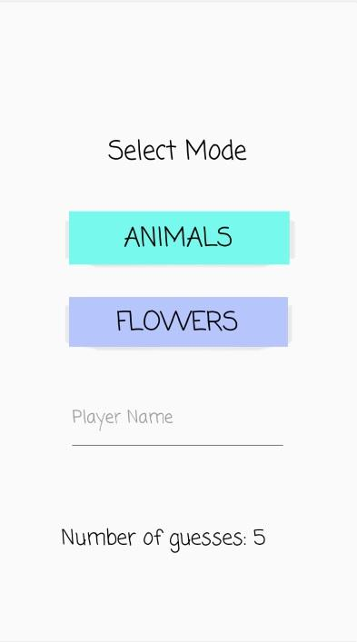 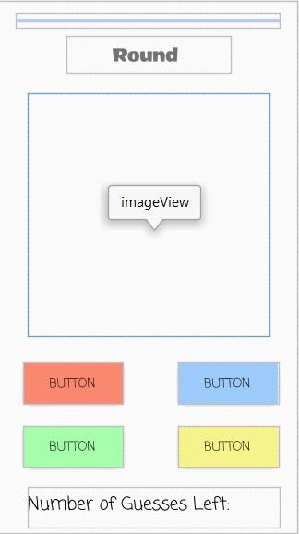

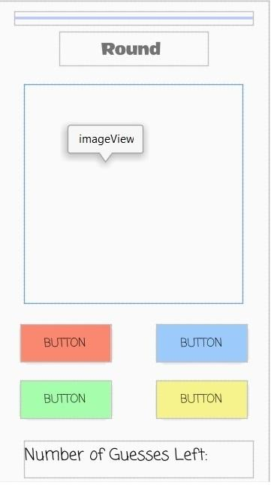 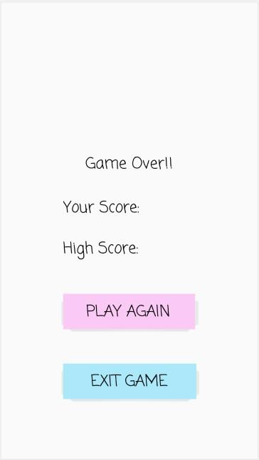

4

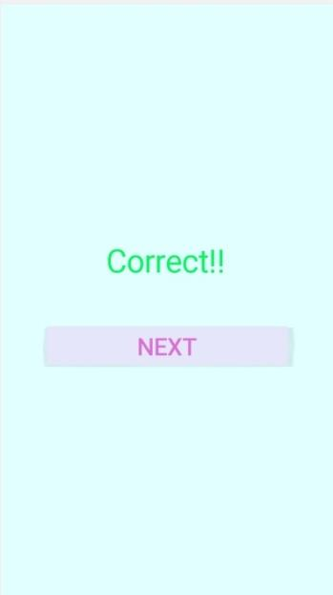

▪**CONTRIBUTIONS**

* DESIGNING THE USER INTERFACE (BY ROLL 59)

The User Interface has been designed according to the instructions of the mentors. The layout is comprised of TextViews, Buttons, ImageView, EditTexts and Progress Bar.

EditText is used for accepting the player name.

ImageView is used for displaying the image of an animal or flower, the name of which has to be guessed.

Buttons have been used for implementing different operations like submitting player name, selecting an option corresponding to an image, play again and exit from the app.

ProgressBar is used to implement a countdown timer.

* ANIMAL AND FLOWER ACTIVITY (BY ROLL 60)

The App consists of Main Activity, Animal Activity, Game Activity and EndGame Activity. The App starts by loading the Main Activity.

In the Main Activity, the user has to choose between Animal and Flower. Upon choosing one, user has to enter a player name. If no name is entered then a message is displayed telling the user that he/she has to enter a player. Then the user is taken to the page corresponding to the button Animal or Flower.

5

Animal Activity and Game Activity are quite similar in implementation. When one of them starts say the Animal Activity, the user has to select an option corresponding to an Animal image which is randomly shown. There are 4 choices, which are random selected to an image. On selecting an option it checked if the chosen option is correct. If so then a dialog telling the user is correct is shown. Else a dialog telling the user is incorrect is shown.

After a certain number of rounds of guesses, the user high score is shown in the EndGame activity. Here the user has the choice to play again by pressing on Play Again button or exit the app by Exit Game. If a user plays the game more than once then the current score is compared with previous high score and the higher one is shown.

* REALM (BY ROLL 58)

Realm database is used to store the scores of the players. The database contains the user’s player name and his/her high score. The player name is set as the primary key of the Player class. The Player class is used to store the player data temporarily. Initially the fields corresponding to a player are filled. But when a player plays the game more than once then his high score is queried and compared with the current score.

* COUNTDOWN TIMER (BY ROLL 57)

A countdown timer is implemented using the ProgressBar in the app. When the Animal Activity or the Game Activity starts the timer starts. So the user has a certain time in which he/she has to give his/her choice. By the time timer runs out, if no choice is entered then the next round of guessing starts.

6

* **Screenshots of complete application to indicate implementation**

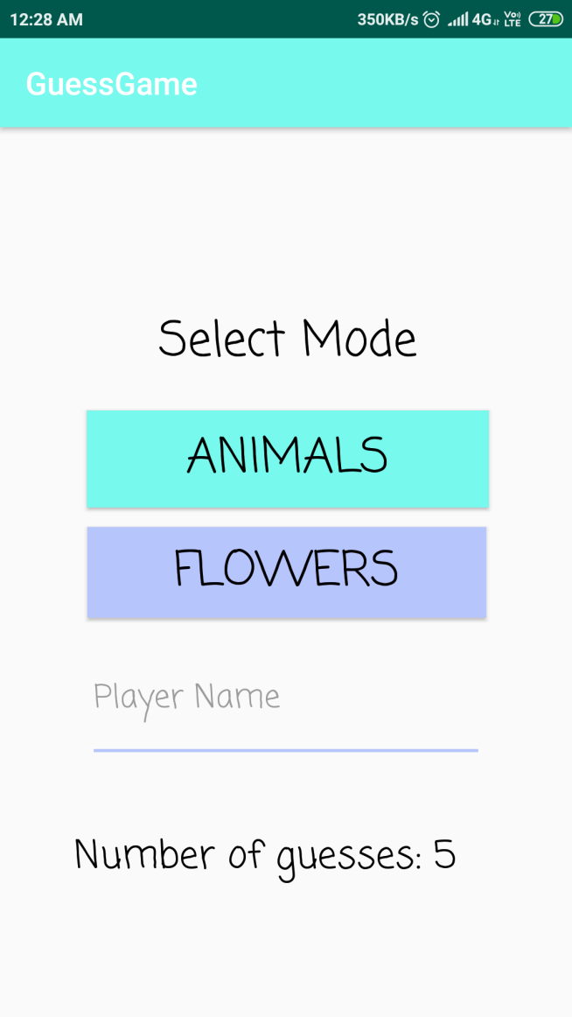 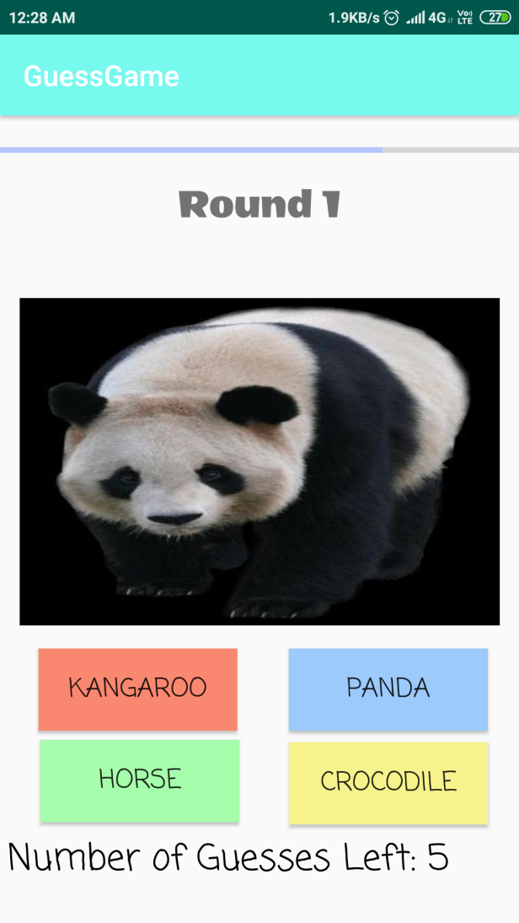

7

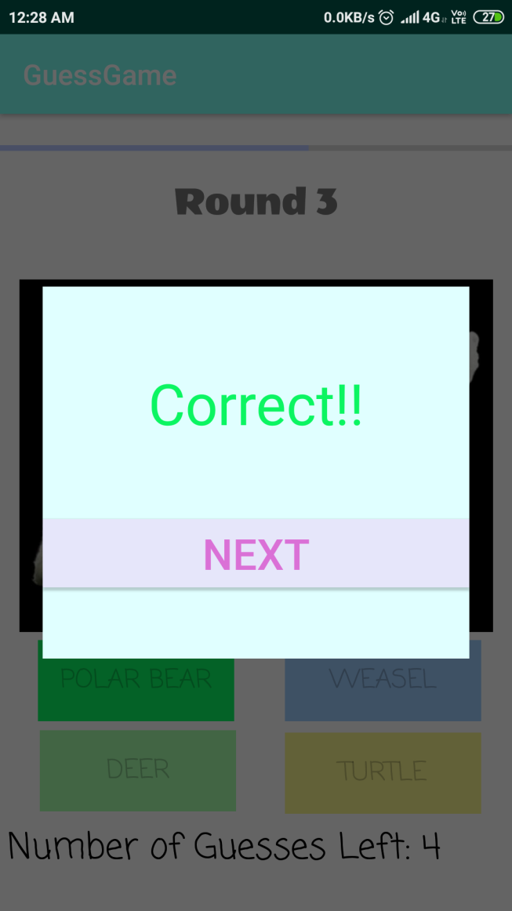 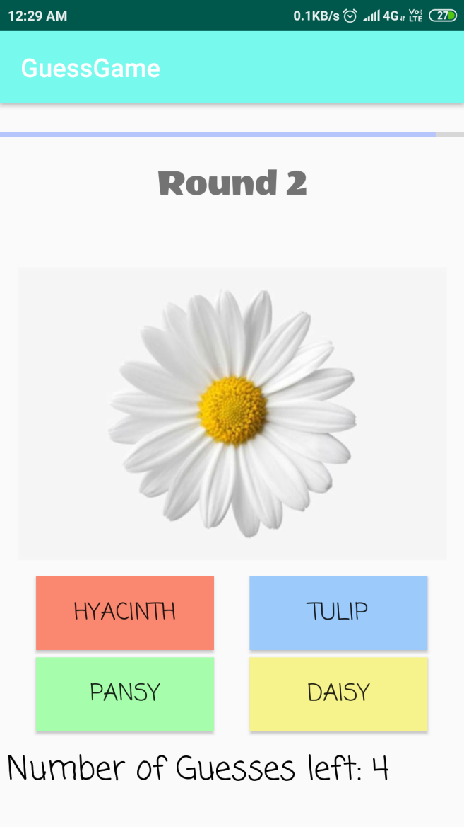

8

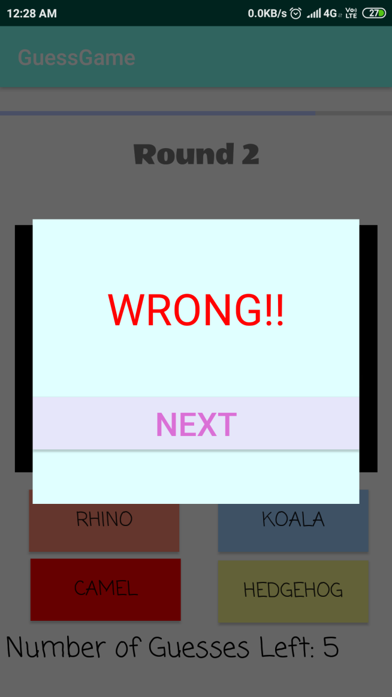 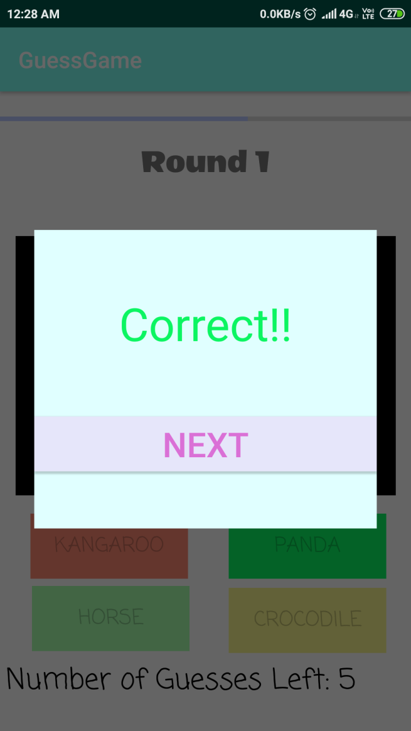

9

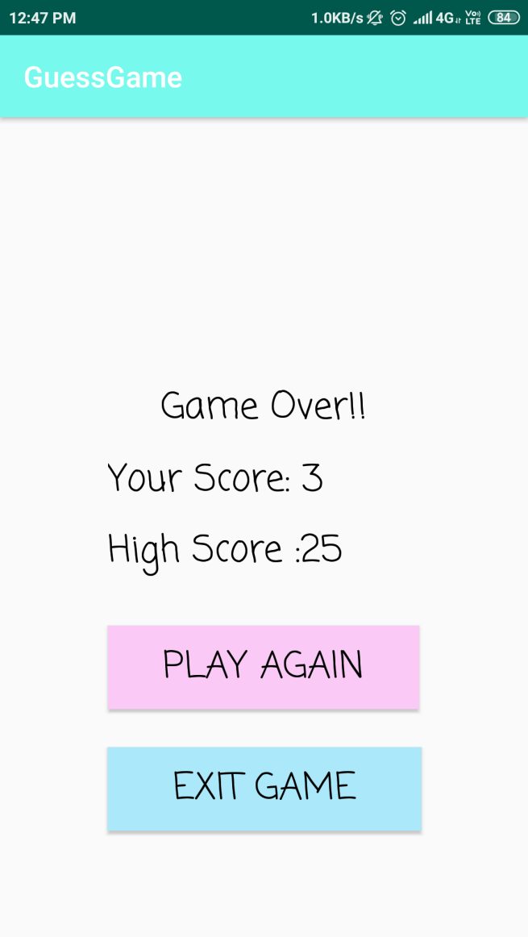 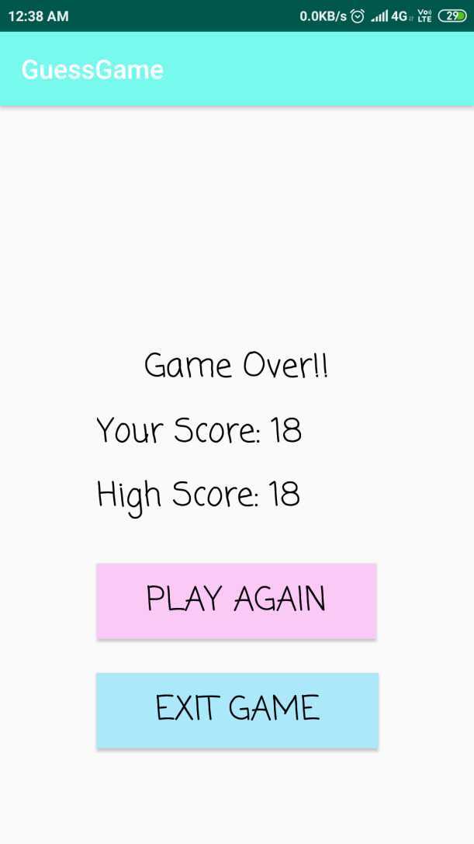

10